Opponents Increase Their Attacks. They Realize Revival is Happening in America
Share:
February 24, 2023
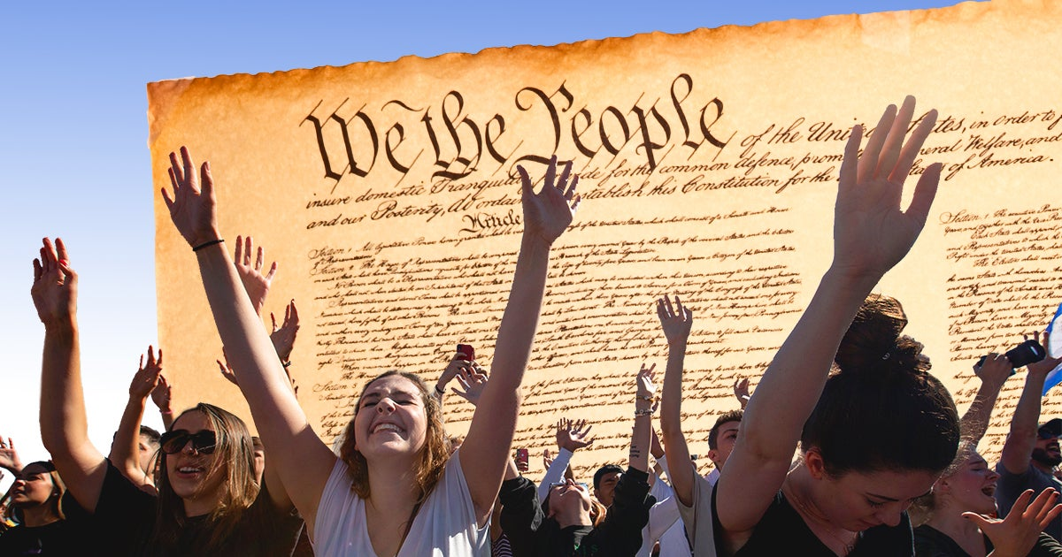
by Mia Gradik & Jorge Gomez • 7 min read
https://firstliberty.org/news/opponents-realize-revival-is-happening-in-america/
You’ll hear about the FBI calling Catholics “potential terrorists”, faith-based pregnancy centers being vandalized and defaced, churches facing discrimination, pastors being denied access to public libraries to read Christian books to children, American workers being fired from their jobs because of their beliefs, and business owners being bankrupted for operating consistent with their faith.
The news might lead us to believe there’s no hope for our First Freedom. But there are a lot of reasons to be hopeful.
Let’s consider this from a spiritual perspective. Attacks are on the rise—but could the enemies of freedom be reacting this way because of what God is doing in our nation?
When our opponents double down and increase their attacks, it just means that what God is doing through us and through YOU is working! This should motivate and spur us to continue fighting for what matters most.
Look at what we have achieved together at the U.S. Supreme Court in recent years. With God’s favor, we secured some of the most important victories of our generation in our Coach Kennedy, Treat Children Fairly and Bladensburg Peace Cross cases. These victories ushered in a new era of religious freedom unlike anything we’ve witnessed in our lifetime.
These were just the tip of the iceberg. Let’s not lose sight of other incredible triumphs for religious liberty we’ve witnessed in just the past five years. Recall these major Supreme Court decisions:
The enemies of freedom know religious liberty in America is on a winning streak. They see how victories in the courtroom are translating to a huge revival for faith and freedom across the country.
Faith and Freedom Being Restored Across America
Virtually everywhere we look, God is doing special things. For every attack on religious liberty, we can also see people, houses of worship and religious organizations living out their faith.
On Super Bowl Sunday, the Christian organization “He Gets Us” ran several ads promoting Jesus. They were quickly met with criticism, which included U.S. Rep. Alexandria Ocasio-Cortez maligning the ads as promoting “fascism.” Despite the outcry, there is a silver lining. Amidst a hostile culture, a religious group is unafraid to spread God’s Word during the biggest and most viewed sporting events in the world.
Remember when Buffalo Bills Safety Damar Hamlin’s heart stopped on the field? Players and coaches immediately knelt and surrounded him in prayer. As the young man fought for his life, America responded by doing much more than simply saying “Our thoughts are with you.” From coast-to-coast, our nation embraced public prayer. We think this had a lot to do with the attitudinal shift regarding religious expression in our country.
Look at what took place at Asbury University in Kentucky. What started as a regular chapel service turned into a massive gathering lasting for weeks. People who attended described the atmosphere as simple, peaceful worship, prayer and repentance. The college president calls it a spiritual awakening. Fox News reported nearly 50,000 people from all over the country flocked to the campus.
These are just a few examples. There’s simply not enough room to cover the millions of expressions of faith happening everywhere else in the country.
Simply put: God is at work. The Supreme Court victories He orchestrated are bearing fruit. There’s no denying it.
After decades of hostility, high school football players and coaches can pray together before their games. “In God We Trust” can be put back in public schools. Chaplains of all faiths can open courtroom sessions with a prayer. Crosses and Ten Commandments monuments can be restored and displayed on public land.
And the best part? This isn’t where the story ends. God isn’t finished. He is creating and blessing us with more opportunities to impact the future.
Five Beacons of Hope
Right now, First Liberty has five cases that could help restore freedom in key areas, including the military, schools, the workplace and houses of worship:
- Gerald Groff, The Faithful Carrier: On April 18, First Liberty will argue at the U.S. Supreme Court on behalf of postal worker Gerald Groff, who was wrongfully forced to quit because of his religious beliefs.
- Fire Chief Ron Hittle: Our client was fired for attending a leadership conference that took place at a church. On March 27, we’ll argue his case in federal appeals court.
- Navy SEALs v. Biden: Earlier this month, we argued our Navy SEALs case in federal appeals court. It could impact thousands of service members who have been punished for requesting legal, religious accommodations to the vaccine mandate.
- His Tabernacle Church: First Liberty is challenging New York’s prohibition on firearms at places of worship. The state allows comparable secular organizations to establish their own policies. On March 20, we’ll argue in federal appeals court behalf of His Tabernacle Family Church. This case could affect houses of worship nationwide and their right to decide how best to protect their congregations.
- Cambridge Christian School: Two private Christian schools were told they couldn’t use the loudspeaker to pray before kickoff at their state championship football game. We will argue this case in federal appeals court on June 26. The outcome could impact students’ and religious schools’ right to exercise their faith.
Despite opponents’ attempts to derail religious freedom, God has been faithful. We should not be discouraged. We should find comfort and strength knowing He continues to be faithful today and will be in the future. Psalm 27:3 reminds us: “Though an army encamp against me, my heart shall not fear; though war arise against me, yet I will be confident.”
We have many victories to celebrate. We’re reclaiming our nation’s heritage of religious expression and restoring the freedoms that were stripped away. But we have a lot of work ahead and many more battles yet to be won. We face intense opposition, so it’s up to us to walk through the doors that God is opening—and continue fighting the good fight.

